1.- Un trancistor 2N3904

2.- un diodo LED (cualquier color)

3.- Placa protoboar (tabla de pruebas)

4.- Bateria de 9v.

5.- 2 cablñes tipo caiman.

6.- Cable compatible con protoboard.

7.- 2 tornillos metalicos.

8.- Un troso pequeño de plastico con dos orificios.

<https://www.youtube.com/watch?v=SllRidANBdc>

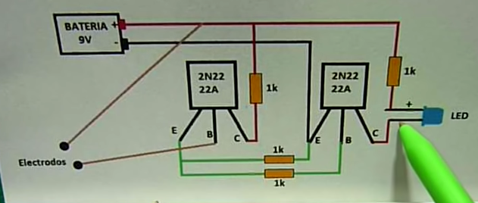

<https://www.youtube.com/watch?v=8Sbl-Od3x8s>

There may be good reasons for choosing the 2N3904 when working at lower current. The 2N4401's higher current capability comes at a cost - higher capacitance and much longer turn off time at low current.

Emitter-Base Capacitance:-

* 2N3904 = 8pF
* 2N4401 = **30pF**

Storage time:-

* 2N3904 = 200ns @ 10mA
* 2N4401 = 225ns @ **150mA**

[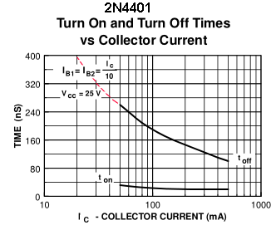](https://i.stack.imgur.com/ApGWH.png)

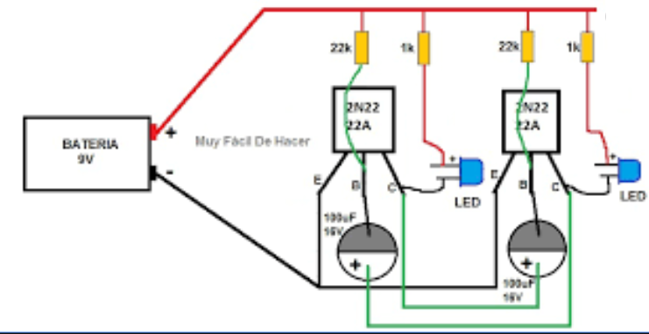

<https://www.youtube.com/watch?v=3EpzPbsU18Q>